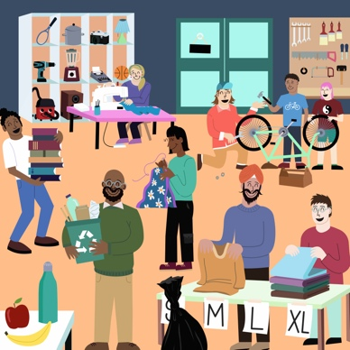 | What is Changeprint?

Changeprint is a new way to describe what happens when local action adds up to collective change. It shows how the power of many can grow into something bigger.
A Changeprint isn’t the project itself – it’s the sum of all the good it generates, such as stronger community ties, healthier environments, more jobs.
Where a carbon footprint measures what we take away, a Changeprint shows what we build together... in simple terms, you shrink a carbon footprint and you grow a Changeprint.

Learn more at: https://carboncopy.eco/changeprint

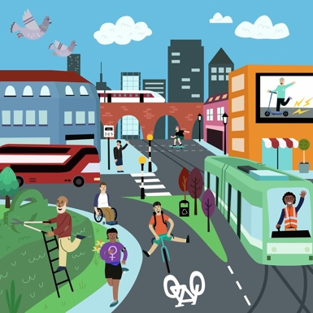 | How does this help you?

Changeprint is a way to talk about climate action in terms beyond emissions reductions that can address a wide range of pressing issues and bring significant benefits to all.
Changeprint helps you describe your impact in a way that gives your work wider recognition and encourages more people to give their time and energy too.
It’s a way to include all the positives, so people see the good that’s generated from taking local action together.

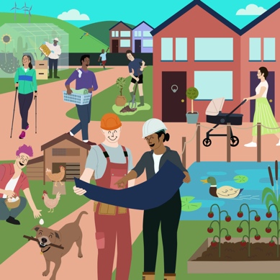 | What’s in a name?

Names have the power to change the world around us.

In talking about a Changeprint, you gather up into one word all the positive benefits of collaborating with others. You have a name that makes things easy to communicate and copy.

Each Changeprint starts locally, then grows as others copy what works and make it their own – creating ripples that move us closer to a social tipping point.

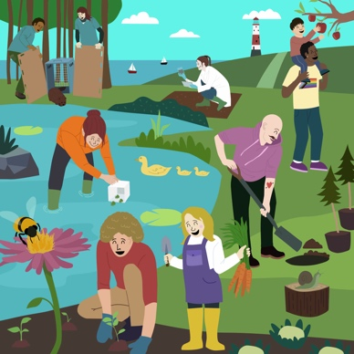 | Why now?

Despite all the news headlines about other things, the climate and nature crisis is not going away.

How are we supposed to keep talking about, and caring about, climate change and pollution and nature, when there’s so much else happening right in front of us?

The good news is that there are a multitude of positive changes already happening close to home. Now is the time to turn towards each other and encourage people to join in.

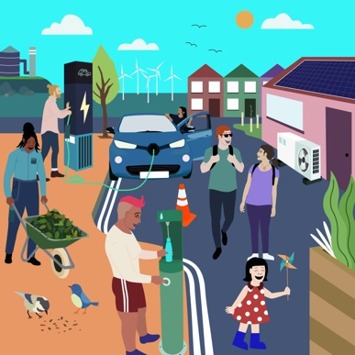 | What does a Changeprint look like?

Warmer homes, vibrant communities, cleaner air, better health and wellbeing, access to fresh food, thriving wildlife… just some of the different benefits that could be part of a Changeprint.

People are taking collective action across the UK, and each one of these groups, projects and organisations has created a Changeprint.

Carbon Copy has published a collection of literally hundreds of stories and Changeprints, highlighting this amazing work. You can read more at: https://carboncopy.eco/initiatives

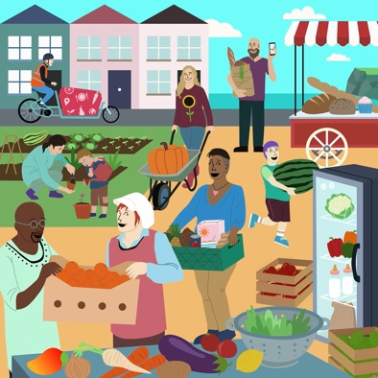 | Changeprints in action

Here are four examples to give you a glimpse of this new, positive way of talking about impact:
Share and Repair A small charity based in the southwest of England, Share and Repair is helping reduce waste and keep items in use for longer through its workshops and borrowing initiatives.
Share and Repair’s Changeprint can be measured by the items fixed instead of thrown away, in their repair cafes; by the items loaned and money saved from not buying new, in their Library of Things; by the people who gain new maintenance skills, in their ‘how to’ workshops; by the electricals re-housed instead of rejected as e-waste.
Maes Gwenfrewi Biodiverse Town Centre Park A former bowling green in the town of Aberystwyth, West Wales, has been repurposed with help from a Challenge for Nature grant into a new wildlife haven and community green space.
Their Changeprint can be measured by the increase in local biodiversity; the number of thriving new trees; the amount of local food grown and enjoyed; and by how the space brings the local community together in different ways.
Safe, Warm and Well Northern Ireland has the highest incidence of fuel poverty in the UK, so this initiative, run by Mid and East Antrim Borough Council, is helping address a significant need for people locally. The service provides advice, support with implementing energy efficiency measures and other health and wellbeing services.
The Changeprint of this service can be measured in terms of community health and wellbeing, improving residents' ability to stay Safe, Warm and Well. Safe, by addressing home safety issues, poor energy efficiency, high energy costs. Warm, by supporting households through the Affordable Warmth grant scheme. Well, by addressing fuel poverty, making homes more comfortable, reducing carbon emissions and providing ongoing referrals for additional support.

Glasgow Food Policy Partnership A group of public, private and voluntary sector organisations who have come together with one specific objective: to create a fairer, healthier, more sustainable and resilient food system that makes Glasgow an even better city to live in.

Their Changeprint can be measured in so many different and far-reaching ways. More equal access to healthy food in all areas of the city. Lower rates of food insecurity. More food procured locally. Higher proportion of food consumed in Glasgow from local producers. More land available for food growing. The development of local and short food supply chains. New employment and training opportunities. Reduced food waste. And last but not least, better health of people in Glasgow longer term.

